**TSNE AFTER THE ENCODER MODEL:--**

gradio

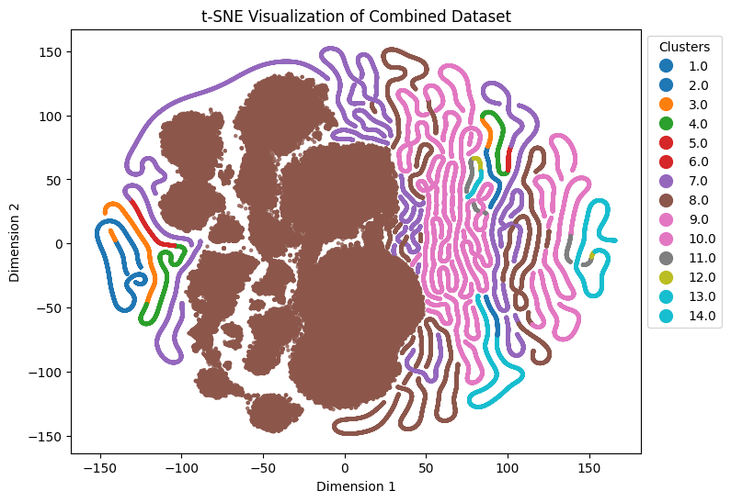

**GRADIO INTERFACE**

